Siemon, Graeme, Dr (includes some details from CRC Wood Innovations website)
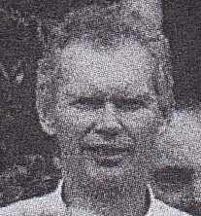
BSc Forestry from ANU, graduated 1966. PhD Australian National University.
With Forests Department in 1980s. Research scientist with CALM, then Principal Research Scientist FPC.
Has 35 years experience in timber technology (including the PhD project), working in this field for the Forest Products Commission WA since its formation in 2000. His experience includes physical and mechanical properties of wood, sawmilling, drying, timber grading, preservation, reconstituted wood products, and effects of silviculture on wood properties and utilisation.
He is a Panel Editor for the ‘Australian Forestry’ Journal, and a part-time lecturer at Edith Cowan University, Joondalup, WA.

